**DEEP LEARNING**

**Lab Assignment -1**

**UMKC**

**Name-Mohammad Mohsin Ali**

**Id-16246618**

**Class Id -26**

**Introduction:** This assignment deals with implementation of logistic regression using tensor flow concepts.

**Task:** implementation of logistic regression using a new dataset, finding its graph and changing the hyper parameter

**Approaches:**

The construction of logistic regression is same that of linear regression, but we have lot more TensorFlow has a wonderful support for batching data, that way we don’t have to calculate every gradient and slow the process.

**Workflow:**

First we imort all the datasets we require for this program

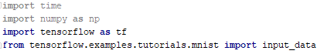

Then import tensor flows built in function to unpack the MINST data and define parameters for the model.

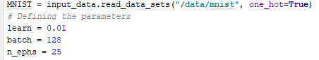

Then we are initializing placeholders and also creating weight and bias with former initialized with random variables with standard deviation 0.01 and b is initialized to 0.

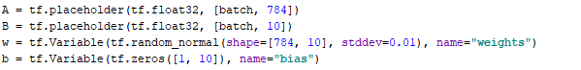

We get B from A, w and b. We are defining loss function and using entropy in it .



Then we define training optimizer and then test the model

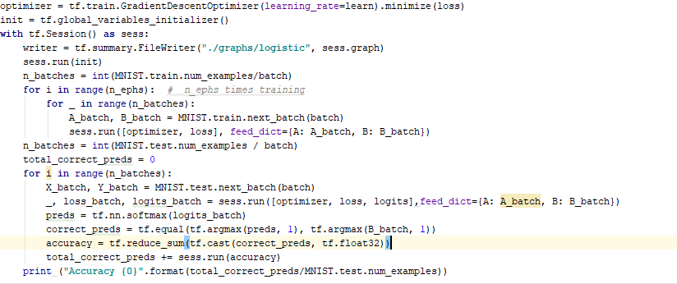

**Datasets:**

The MNIST database (Mixed National Institute of Standards and Technology database) is one of most import datasets used in image processing.it has handwritten digits. The 1-d tensor contains imgage of 28*28 pixels. MINST 55,000 data points of training data.

**Parameters:**

We have take parameters as learning rate=0.01,batch size=128,epouchs=25.

**Evaluation:**

we get output as

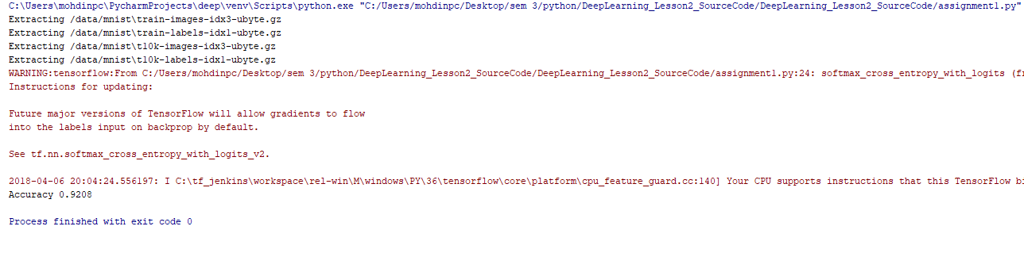

Then we use tensor board to get the graph

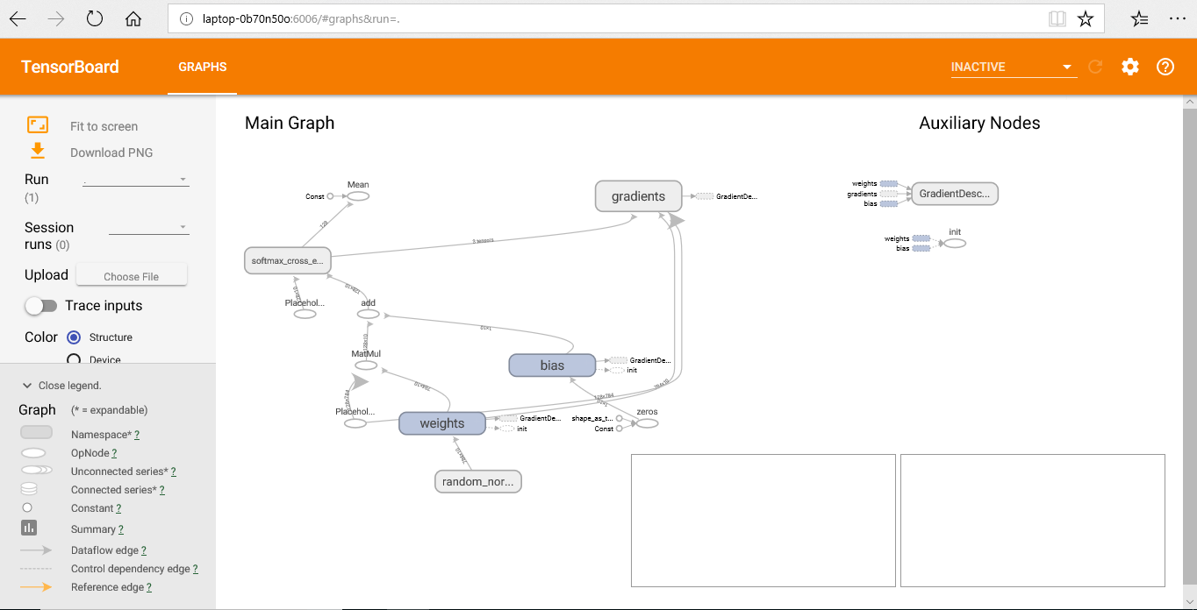

When we change the hyperparameters we get i.e epochs=9

We get



**Conclusion:**

We achieve more than 90% accuracy after 10 epochs. Below 10 epochs we achieve accuracy less than 90%.